Software Application Testing

Assessment task 1

Ciarán Maher 14/12/2015

KTQ0855

Testing

Contents
Introduction 2
Methodologies 3
Black-Box Testing 3
White-Box Testing 3
Grey-Box Testing 3
Evaluation 3
Black-Box Testing 3
White-Box Testing 3
Grey-Box Testing 4
Scenarios/Case Studies 4
Compare and Contrast all three methodologies 4
Tools/Techniques used 4
Conclusions 4
Bibliography 6

Introduction
Will submit introduction in final draft.

Methodologies

Black-Box Testing
Black-box testing is a method of software testing that examines the functionality of an application without peering into its internal structures or workings. This method of test can be applied to virtually every level of software testing: unit, integration, system and acceptance.
(Black-Box Testing, 2015)

White-Box Testing
White-box testing (also known as clear box testing, glass box testing, transparent box testing, and structural testing) is a method of testing software that tests internal structures or workings of an application, as opposed to its functionality (i.e. black-box testing).
(White-box Testing, 2015)

Grey-Box Testing
Grey-box testing (International English spelling: grey-box testing) is a combination of white-box testing and black-box testing. The aim of this testing is to search for the defects if any due to improper structure or improper usage of applications.
(Grey-box testing, 2015)

Evaluation

Black-Box Testing
Black Box testing is the process of giving input to the system and checking the output of the system without bothering how the output is generated.

- It refers to testing a system without knowledge of specification to the internal workings of the system, access to the source code, and knowledge of the architecture. Essentially this approach mimics in a close approach, how an attacker typically follows approach to the application. However, the uncovering of issues or vulnerabilities could be further longer, because of lacking internal application knowledge.
- Black box testing is done at an outer level of the system. Test cases merely check if the output is correct for the given input.
- The team tests the system without any knowledge of how the system is being made.
(Testing White-box, Black-box, Grey-box, 2015)

White-Box Testing
White Box (or glass box) testing is the process of giving input to the system and checking how the system processes input to generate output.

- It refers to the testing a system with full knowledge and access to all source code and other architecture documents. This testing enables to reveal bugs and vulnerabilities quickly in comparison with trial and error method. More complete testing coverage is ensured by exactly knowing what to test.
- White box testing involves thorough testing of the application. It requires knowledge of code and the test cases chosen verifies if the system is implemented as expected. It typically includes checking with the data flow, exceptions, and errors, how they are handled, comparing if the code produces the expected results. E.g. In electrical appliances the internal circuit testing.
- The team tests the internal logics of the code. The code for the application is tested. It is also known as the glass box testing.
(Testing White-box, Black-box, Grey-box, 2015)

Grey-Box Testing
Grey Box testing is a combination of White Box and Glass Box Testing. In this, the tester has little knowledge about the internal working of the software; so he tests the output as well as process carried out to generate the output.

- It refers to a testing system by knowing limited information about the internals of the system. The knowledge is always limited for detailed design documents and architecture diagrams. In concise, it is a good blend of black and white box testing, which leverage the strengths of each.
- Grey box testing is a combination of both black box and white box testing. This is because it involves access to the system; however, at an outer level. A little knowledge of the system is expected in Grey box testing.
- Both white box and black box combined are known as grey box testing.
(Testing White-box, Black-box, Grey-box, 2015)

Scenarios/Case Studies
This is an example of Black-box testing
Web Service Example: To illustrate Black Box testing for a sample Web Services, an operation Divide that simply divides to integers a and b. The Black Box tester is unaware of what operating system, programming language, 3rd party libraries or other Web Services are being used under the hood to perform the Divide operation.
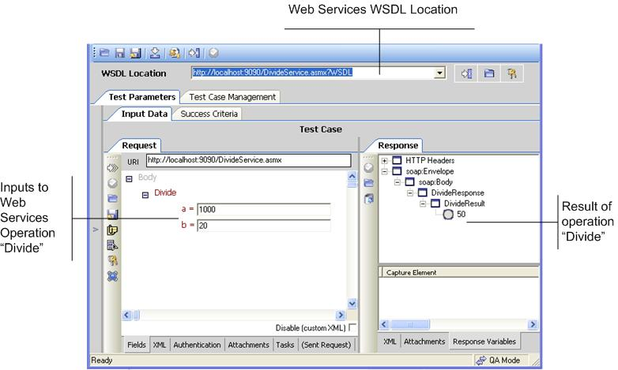
As shown in Figure 1, the Black Box tester has the ability to insert inputs to the operation and look at outputs. The tester may know that the Web Services WSDL is located but is completely oblivious of implementation details, program execution states, and internal exception handling. The tester has a specification and goes through a rigorous, time-consuming and oftentimes redundant exercise of trying values and ensuring that the operation Divide functions as expected.
(SOA Testing Techniques, 2005)

Compare and Contrast all three methodologies
Black-box testing differs from White-box testing and Grey-box testing, in that it requires no knowledge of the system being tested other than the inputs expected by the system and the desired outputs of the system.

White-box testing differs from Black-box and Grey-box testing, in that it requires in-depth knowledge of the system. While it follows a similar pattern as Black-box testing, in that the tester must input values into the system; it also requires the tester to examine the internal workings of the system, the source-code and the architecture of the system.
Grey-box testing differs from both Black-box testing and White-box testing in that it combines elements of both methodologies, while not being as thorough in either respect.

Tools/Techniques used
Protractor is an example of a black-box test framework for AngularJS applications. Protractor runs tests against your application running in a real browser, interacting with it as a user would.
Karma is an example of a white-box test framework for AngularJS applications. Karma directly hooks into, and injects data into the program that is to be tested.
Cem Kaner defines "grey-box testing as involving inputs and outputs, but test design is educated by information about the code or the program operation of a kind that would normally be out of view of the tester". Grey-box testing techniques are:
- Matrix Testing: states the status report of the project.
- Regression testing: it implies rerunning of the test cases if new changes are made.
- Pattern Testing: verify the good application for its design or architecture and patterns.
- Orthogonal array testing: used as subset of all possible combination.

Conclusions
Will submit conclusion in final draft.

Bibliography
SOA Testing Techniques. (2005). Retrieved 01 04, 2016, from Cross Check Network: http://www.crosschecknet.com/soa_testing_black_white_gray_box.php
Black-Box Testing. (2015, 12 6). Retrieved 12 14, 2015, from Wikipedia: https://en.wikipedia.org/wiki/Black-box_testing
Grey-box testing. (2015, 07 9). Retrieved 12 14, 2015, from Wikipedia: https://en.wikipedia.org/wiki/Gray_box_testing
Testing White-box, Black-box, Grey-box. (2015). Retrieved 12 14, 2015, from CareerRide: http://www.careerride.com/Testing-white-box-black-box-gray-box.aspx
White-box Testing. (2015, 12 6). Retrieved 12 14, 2015, from Wikipedia: https://en.wikipedia.org/wiki/White-box_testing

